Casey Gray
ITEC 4365
January 31, 2025
Program 1

Instructions
Screen capture your source code and output and paste it into a Word document. Submit your Word document by the due date.

Code:
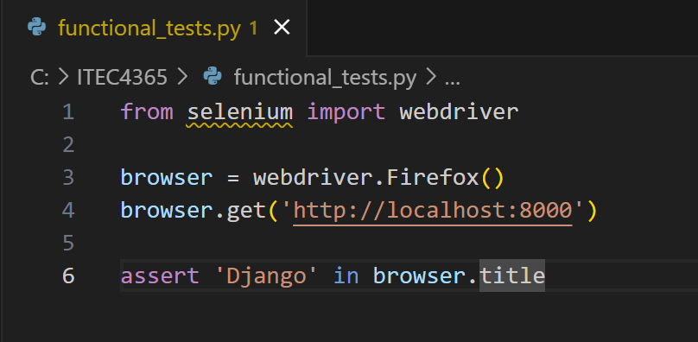

Console:
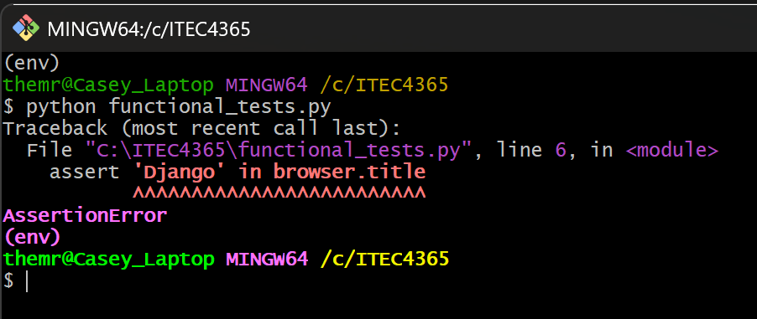

Browser:
